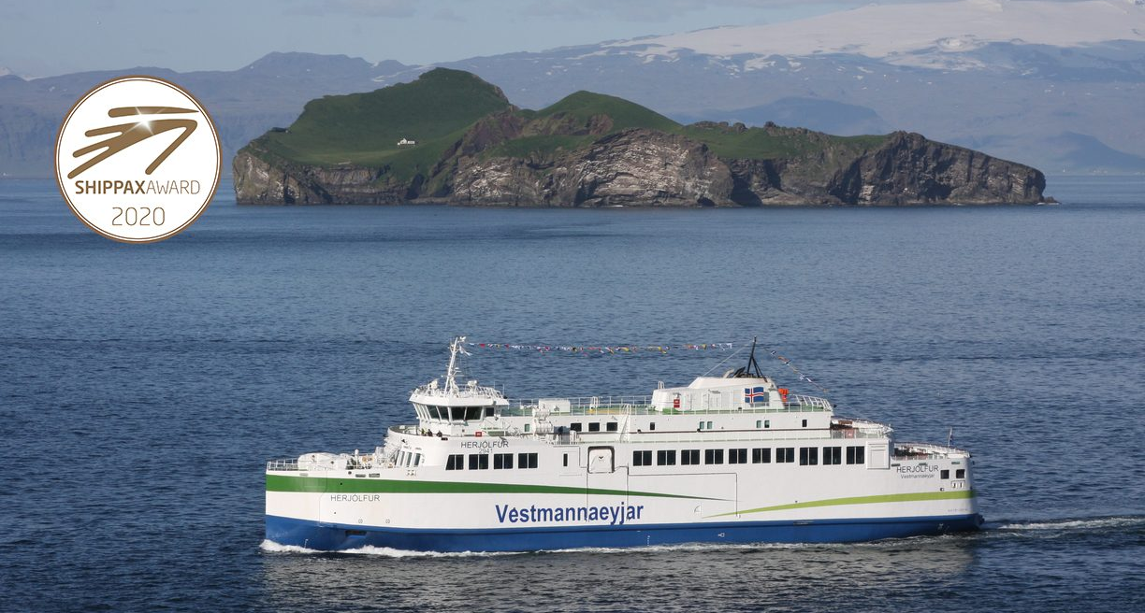
Main dimensions
Length over all approx. 69,38 m
Length car deck 63,80 m
Beam extreme 15,50 m
Depth moulded to main deck 5,10 m
Design draught, mld max 2,80 m
Max loaded draught, mld max 3,00 m
Capacities Lane capacity min 342 m
Passenger capacity summer 540 pers.
Crew 10 pers.

Class: DNV ✠ 1A1 – CAR FERRY A – E0 – BATTERY SAFETY – BIS
Speed and Power
Power output , diesel generators 3700 kW
Power output , battery 3300 kW
Total long term output, approx. 4 000 kW
Generators & batteries
Trial speed on design draught min 15,0 knots

Thrusters
Forward, 2x FP electric driven bow thruster 600 kW

Navigation & communication
Radars, DGPS, CCTV, auto pilots, gyro and chart system installed as an integrated system. All communication equipment to be in accordance with the requirements described in SOLAS Ch.4 for sea area A2. The wheelhouse to fulfil XSYS-NEQ 1 and XAUT-UMS notation for one man operation both at sea and during manoeuvring.

Propellers
2x azipull thrusters 1700 kW at 1600 RPM.

Diesel Generators
For electric power production, 3x diesel generator sets, each with a
capacity of about 1350- 1450 kVA (1200-1300 kW) at approx.
1500/1800 RPM

Emergency Diesel Generators
1x emergency diesel generator set, with a capacity of about 165 kVA at 1800 RPM

Propulsion support batteries
- Total capacity: 3300 kW

General data about the design & design highlights

Our PK-259.1 (MF Herjólfur) is a tailor-made design for the Vestmannaeyjar connection between Heimaey and Landeyjahöfn in Iceland. She was delivered from Crist Shipyard, Poland in 2019 for the Owner Vegagerðin, the Icelandic Road Authorities.

The vessel is designed and equipped to meet these conditions by excellent manoeuvrability and shallow water seakeeping.

The vessel is fully electric with a 3 MWh battery pack and rotatable pulling thrusters of 2 x 1700 kW.

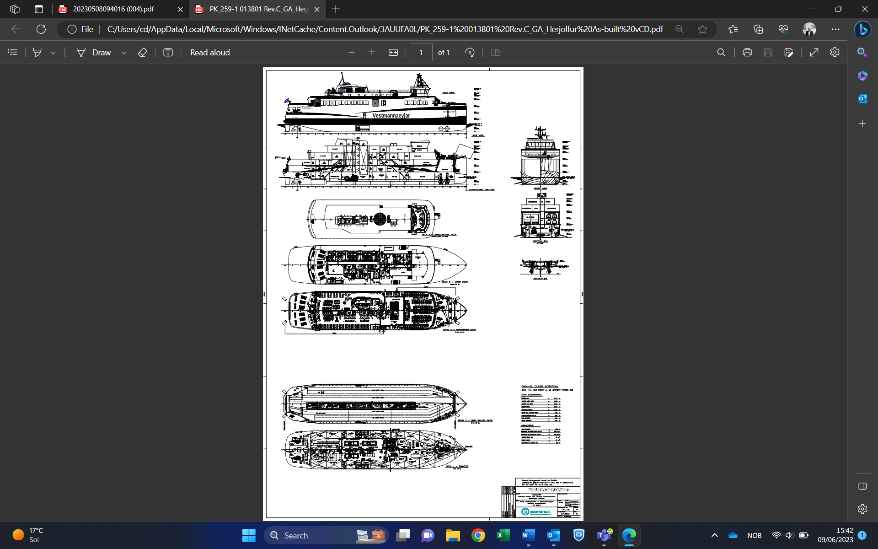

General data about PK

Polarkonsult AS was established in 1974 and is one of the leading independent consultant companies within ship design and naval architecture in Norway. We deliver ship design, inspections and survey for the global market. Engineering and documentation for the energy, oil and gas sector is a growing activity.
​
Our customers’ requirements have top priority and our philosophy is to be a reliable and competent supplier of modern technology for the future.

